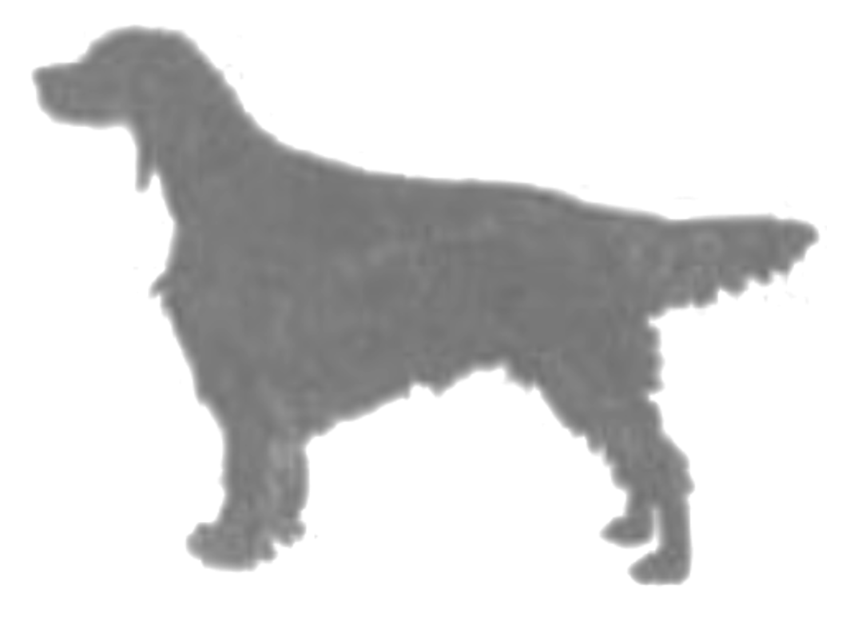  BELFAST and DISTRICT IRISH SETTER CLUB  OPEN SINGLE BREED SHOW  Held under Kennel Club Limited Rules & Regulations  Venue: Canine Academy, 28 Moneybroom Road, Lisburn, BT28 2QP  Date of Show: 9th June 2018 |  |  |  |  |  | First entry per dog @ £8 any number of classes including catalogue  Additional dog entry @ £2 any number of classes  Membership: £8 single; £12 joint; £3 junior  For Secretary’s use – membership?  Enclosed cheques / POs payable to:  Belfast & DISC Total: £_________  ENTRIES CLOSE: 12th May 2018 (Postmark)  On no account will entries be accepted without fees.
This form must be used by one person only (or partnership). Writing MUST BE IN INK OR INDELIBLE PENCIL. Use one line only for each dog. The name of the dog and all the details as recorded with the Kennel Club must be given on this entry form. If an error is made the dog may be disqualified by the Committee of the Kennel Club. All dogs must be REGISTERED at the Kennel Club in the name of the exhibitor. If the registration or transfer of ownership has not been confirmed it must be applied for before the closing date of entries. In case of dispute proof of postage of such applications may be required by the Kennel Club. Puppies under 6 months of age on the first day of the Show cannot be entered for competition. On no account will entries be accepted without fees. If a dog is in the process of Registration or Transfer at the time entry is made, add the letters NAF or TAF as appropriate after its name. Please put classes in numerical order and USE BLOCK CAPITALS throughout when completing this entry form. The Kennel Club Authority to Compete number (for dogs registered and resident outside the UK) must be stated or the entry will be returned.
PLEASE CHECK ALL DETAILS BEFORE POSTING
REGISTERED NAME OF DOG  (Block Capitals & ATC Number if applicable) | BREED | SEX  (D or B) | Full Date of Birth | BREEDER  (Block Capitals) | SIRE  (Block Capitals) |  | DAM  (Block Capitals) | Entered in Class No.
 | Irish Setter
Kennel Club ATC No:
 | Irish Setter
Kennel Club ATC No:
 | Irish Setter
Kennel Club ATC No:
Only undocked dogs and legally docked dogs may be entered for exhibition at this show. A dog which had its tail docked on or after 1st January 2013 cannot be shown at events where the exhibitor pays a fee or members of the public pay an admittance fee. |  |  |  | In the case of joint registered ownership the name of every owner must be given here: Block Letters Please  Name of Owner(s) …………………………..…………………………………………………………………………  Address …..…….……………………………..………………………………………………………………………….…  …………………………………………………………………………………………………………………………………...  Postcode …..…..……………………… Telephone No. ……………………………...................................…  Email ……………………………................................................................... Date: …………………………..  Your address will be printed in the catalogue unless you tick here:  ENTRIES AND FEES, WHICH MUST BE PREPAID, TO BE SENT TO:  Ms K McKelvey, 49 Ballynahonemore Road, Armagh, BT60 1HY  Email: edenaveys@gmail.com; Tel: 02837 523981; 07742 488021
DECLARATION
I/We agree to submit to and be bound by Kennel Club Limited Rules & Regulations in their present form or as they may be amended from time to time in relation to all canine matters with which the Kennel Club is concerned and that this entry is made upon the basis that all current single or joint registered owners of this dog(s) have authorised/consented to this entry. I/We also undertake to abide by the Regulations of this Show and not to bring to the Show any dog which has contracted or been knowingly exposed to any infectious or contagious disease during the 21 days prior to the Show, or which is suffering from a visible condition which adversely affects its health or welfare or to bring any dog which has been prepared for exhibition contrary to Kennel Club Regulations for the Preparation of Dogs for Exhibition F (Annex B). I/We agree without reservation that any Veterinary Surgeon operating on any of my/our dogs in such a way that the operation alters the natural conformation of the dog or part thereof may report such operations to the Kennel Club. I/We declare that where any alteration has been made to the natural conformation of the dog(s) the relevant permission to show has been granted by the Kennel Club.

I/We further declare that I believe to the best of my knowledge that the dogs are not liable to disqualification under Kennel Club Show Regulations.

Usual Signature of Owner(s) …………......................................……........................................... Date .....................................

NOTE: Dogs entered in breach of Kennel Club Show Regulations are liable to disqualification whether or not the owner was aware of the breach. NOTE: Children under the age of 11 are the responsibility of and must be accompanied at all times by a Parent or Guardian.

ABCSDS, http://abcsds.co.uk/Dog_Shows.htm
Samuel Robinson, 15 Manse Road, Kircubbin,
Co. Down, NI, BT22 1DR, enquiries@abcsds.co.uk

REGULATIONS FOR THE PREPARATION OF DOGS FOR EXHIBITION

1. These Regulations must be observed when a dog is prepared for exhibition and/or exhibited at any Kennel Club Licensed event. Objections may be referred to the Board for disciplinary action under these Show Regulations and/or for disciplinary action under Kennel Club Rule A11.
(a) A dog found to have been exhibited in breach of these Regulations will automatically be disqualified from exhibition at the show and from any award gained thereat.
(b) Unless the exhibitor provides a satisfactory explanation for the dog being exhibited in breach of these Regulations then he/she may be subject to further penalties of either a fine or as listed under Rule A11.

2.(a) No substance which alters the natural colour, texture or body of the coat may be present in the dog's coat for any purpose at any time during the Show. No substance which alters the natural colour of any external part of the dog may be present on the dog for any purpose at any time during the Show.
(b) Any other substance (other than water) which may be used in the preparation of a dog for exhibition must not be allowed to remain in the coat or on any other part of the dog at the time of exhibition.

3. No act or operation which alters the natural conformation of a dog or any part thereof may be performed except:
(a) Operations certified to the satisfaction of the Board.
(b) The removal of dewclaws of any breed.
(c) Operations to prevent breeding provided that such operations are notified to the Kennel Club before neutered dogs are shown.
Nor must anything be done calculated to in the opinion of the Board to deceive.

4. The Board without previous notice may order an examination of any dog or dogs at any Show. Any examination thus ordered will be made by a person having executive authority who shall have a written directive from the Kennel Club in their possession. Samples may be taken for further examination and analysis.

5. An individual has the right to lodge an objection to a dog only if he/she is the owner or handler of a dog competing in the same breed or class. An objection may, however, be lodged by an official of the Show or by anyone so deputed by the Kennel Club. It will be the responsibility of the individual who lodges the objection or the official (as appropriate), to substantiate the grounds for the objection. The Kennel Club will substantiate the grounds for an objection made on its behalf.

6. Any objection by an individual related to an infringement of these Regulations must be made in writing to the Show Secretary at his/her office before the close of the Show and the individual must produce evidence of identity at the time of lodging the complaint.

Your dog is vulnerable and AT RISK if left in a vehicle in high temperatures and even on days considered as slightly warm. Please take care of your dog.

If your dog is found to be at risk, forcible entry to your vehicle may be necessary without liability for any damage caused.

