NORTH OF IRELAND PEKINGESE CLUB
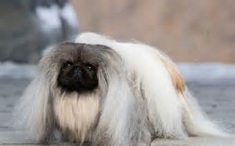
Membership Application Form
£6.00 Single £10.00 Joint
I/ We hereby apply for membership of The North of Ireland Pekingese Club and if accepted, agree to abide by the Rules, Regulations and Code of Ethics of The Club.

Name of Applicant (Applicants, if joint membership)

__________________________________________________________________________________

Address of Applicant/s (joint members must live at same address)

_______________________________________________________________________________________________________________________________________________________________________________________________________________________________________________
Tel : __________________________ email :___________________________________

The Proposer and Seconder must be fully paid up members of The Club.
Name of Proposer Name of Seconder

________________________________ _____________________________

Signature of Proposer Signature of Seconder

________________________________ _____________________________

Please return form and remittance to:
Evelyn Blevins, Hon. Secretary, 23 Derryhubbert Road, Dungannon, Co Tyrone, BT71 6NW.

